Task 1 Get request to get the Hostname Using POSTMAN tool

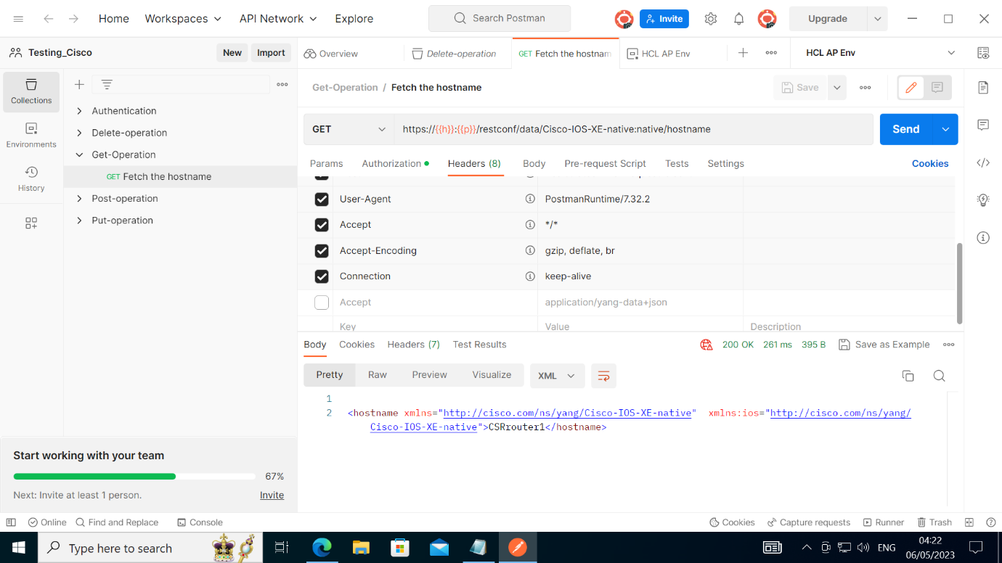

Router Details:

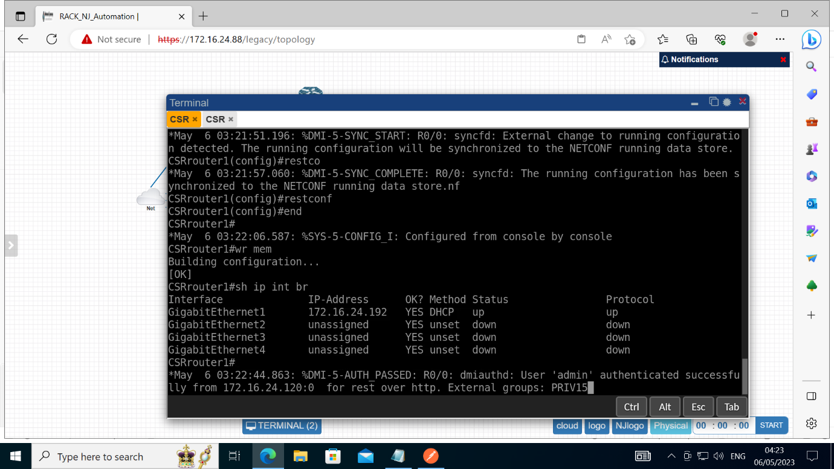

Connected Device IP:

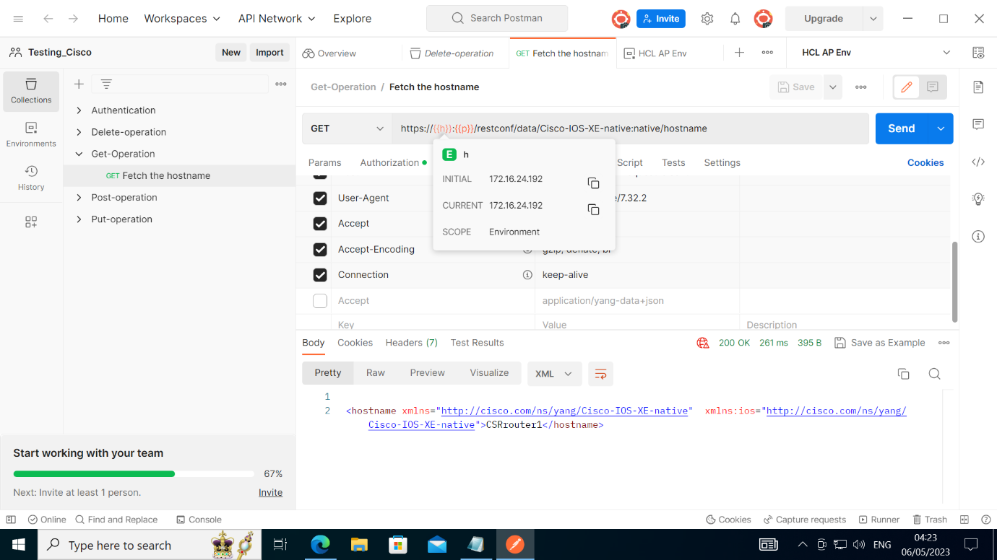

Get the JSON value:

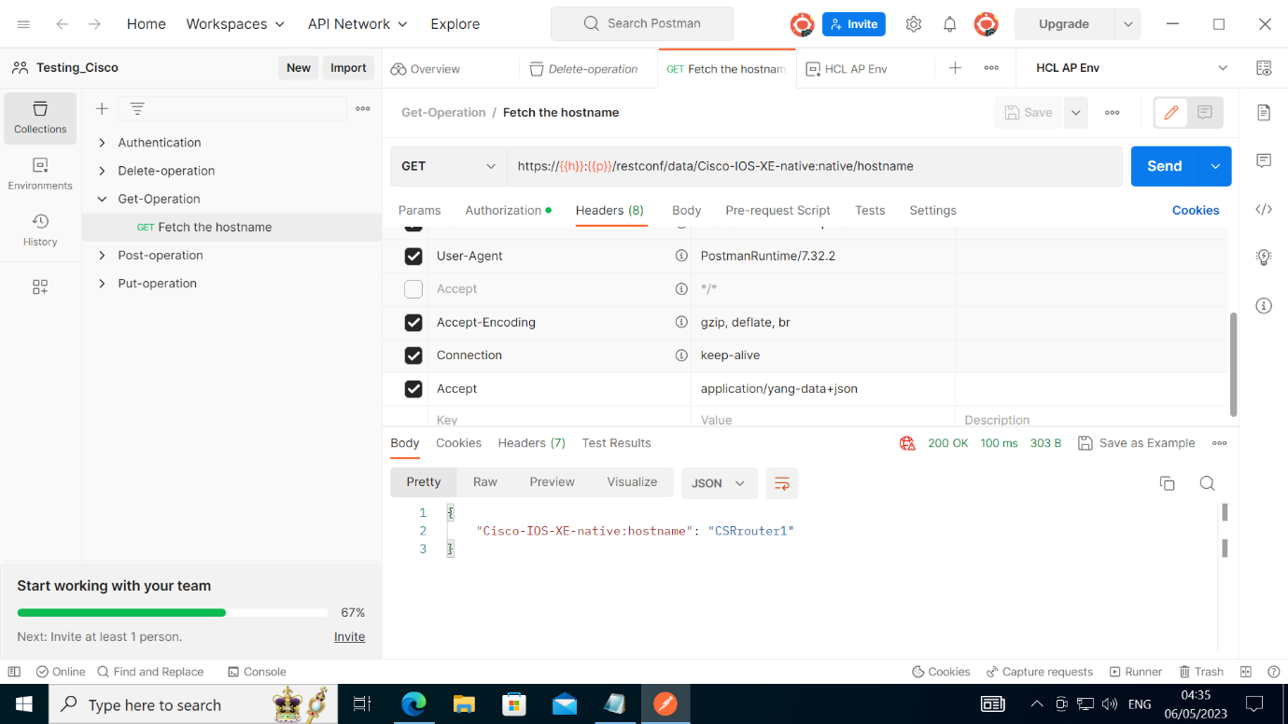

Task 2:

Post request using POSTMAN tool

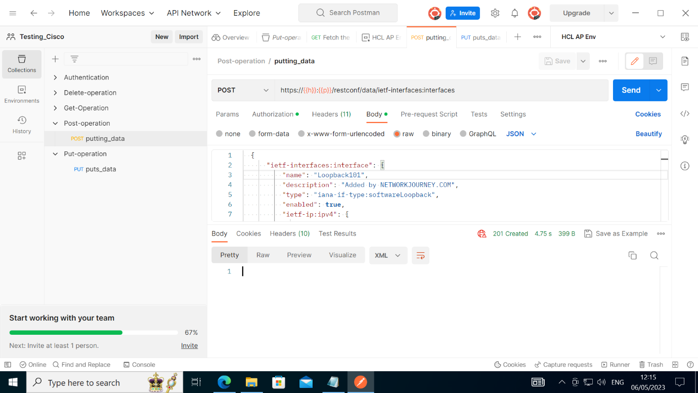

Device IP:

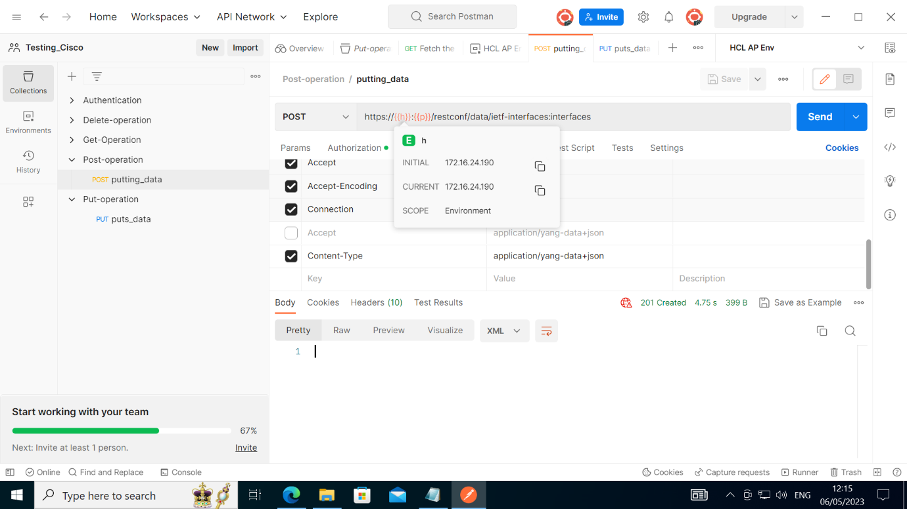

LOOPBACK is created and submitted:

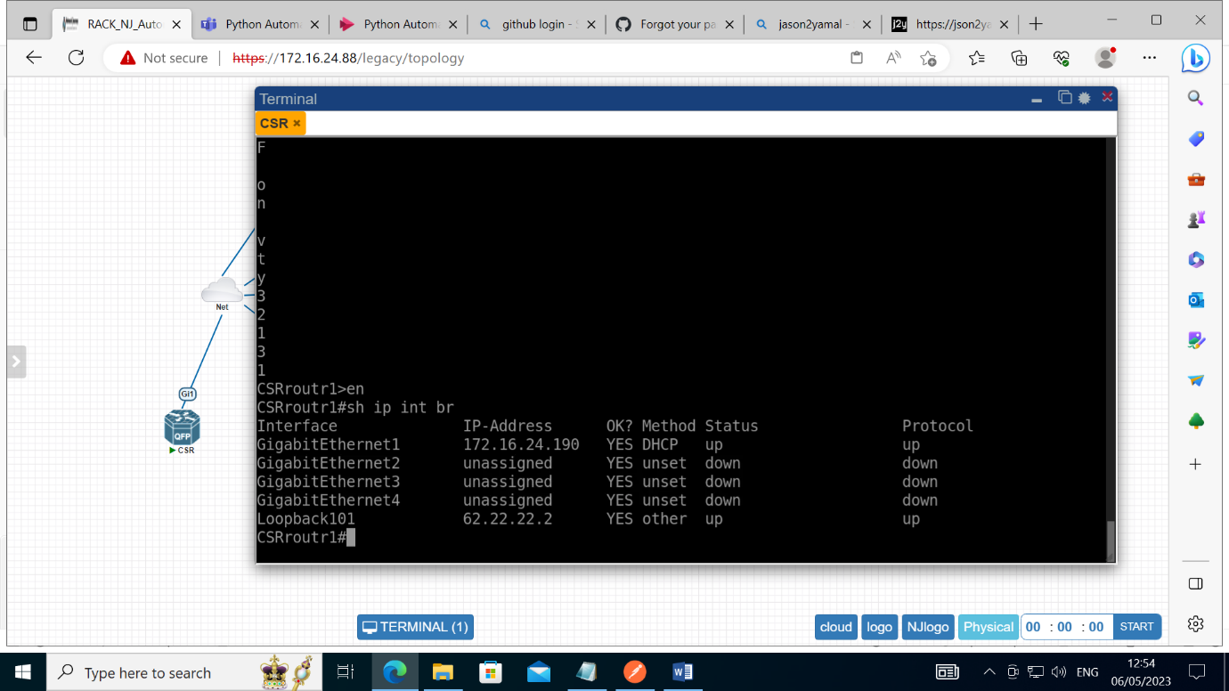

Task 3:

PUT Method Using POSTMAN tool

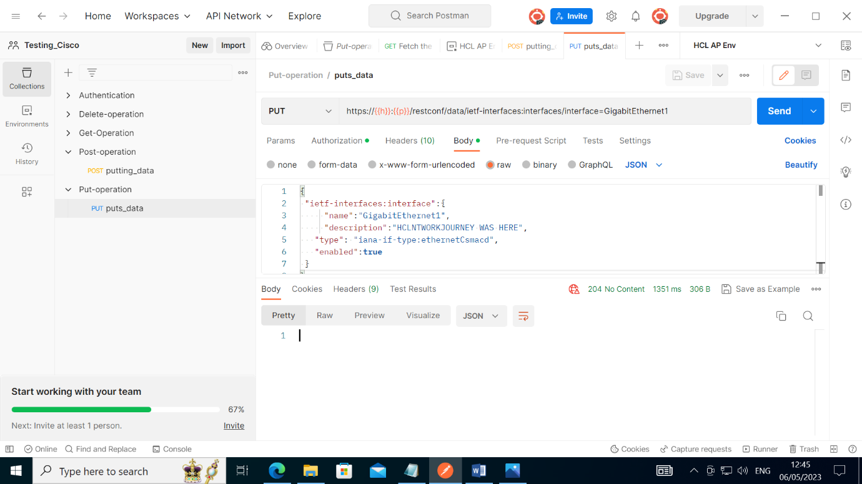

HEADERS Content type:

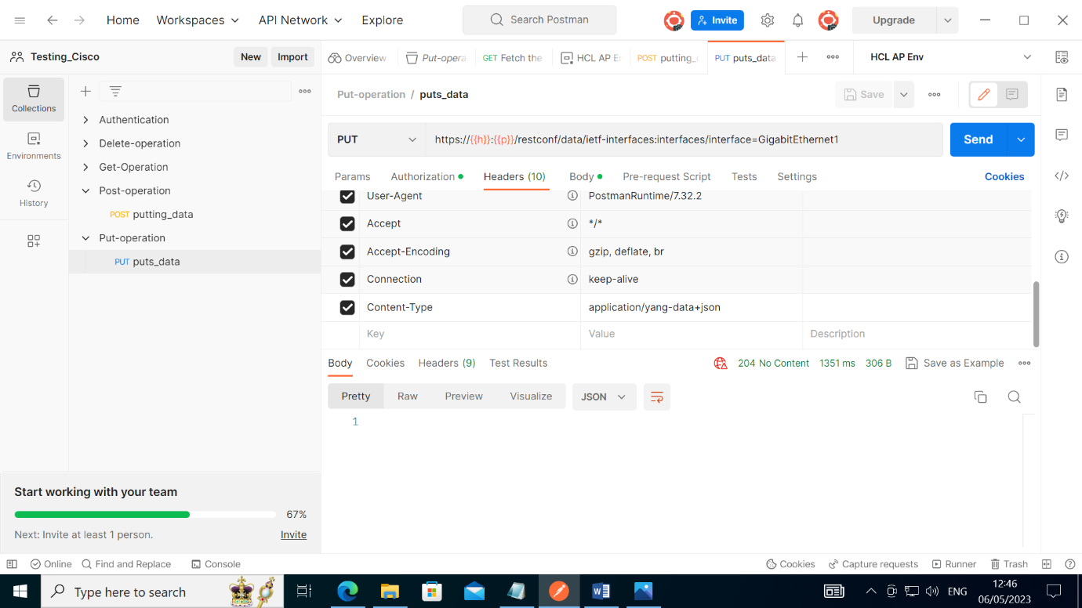

Task 4:

Delete Request by using POSTMAN tool

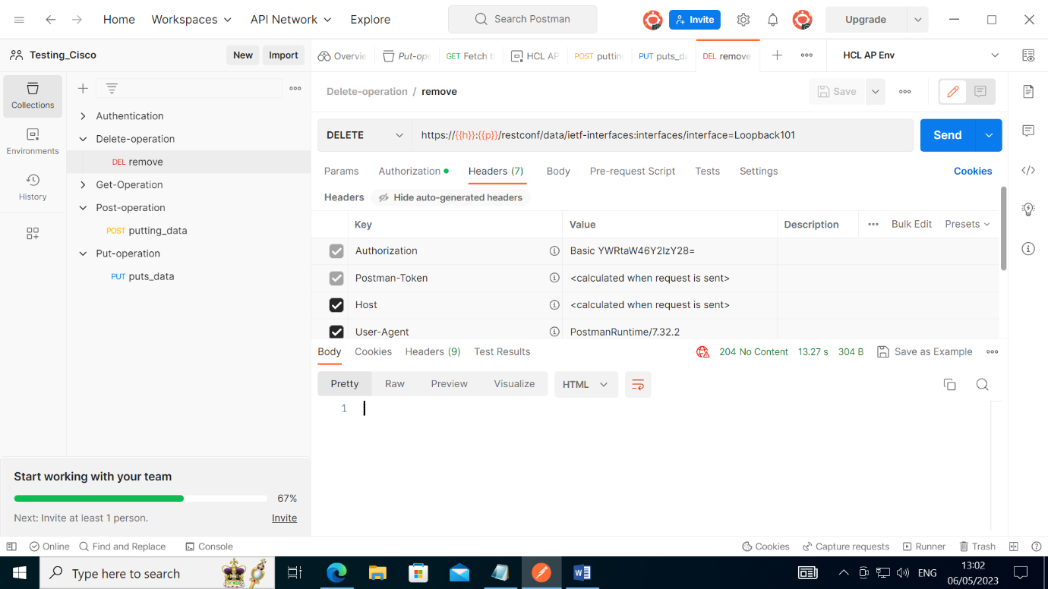

Request applied on router table LOOPBACK101 is deleted:

